Name:_____________________________
Class:_____________________________

Clarify
Clarify - This is the most important step in the process of inquiry and if not done with authenticity will stifle the rest of the process. It takes about 10% of the time and most of this time is spent thinking. The easiest way to describe this step is that it is the filtering step. Inquirers have to consider the information they have gained in the connect stage and now need to filter out the parts of the concept that most interest them.
Filter by engagement
not by direction
It is critical that this is filtering is done through interest/ engagement and is directed. This step is about clarifying understanding and knowledge, while wondering about what next. Creating question / lines of inquiry require effort (cognitive) and are not easy, but the familiar the inquirer becomes with the frameworks the more confident they will become with asking the questions.

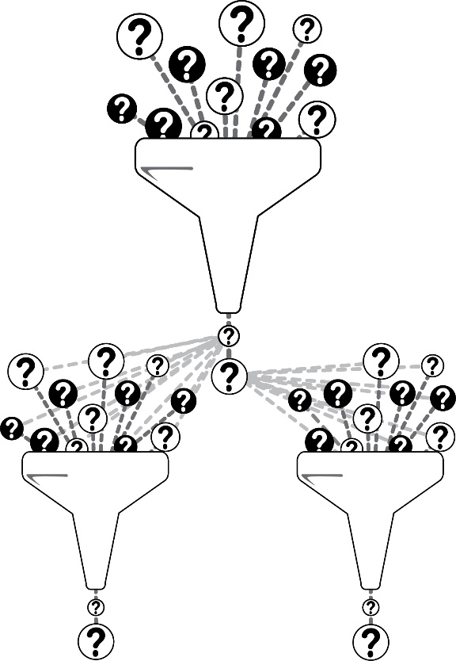

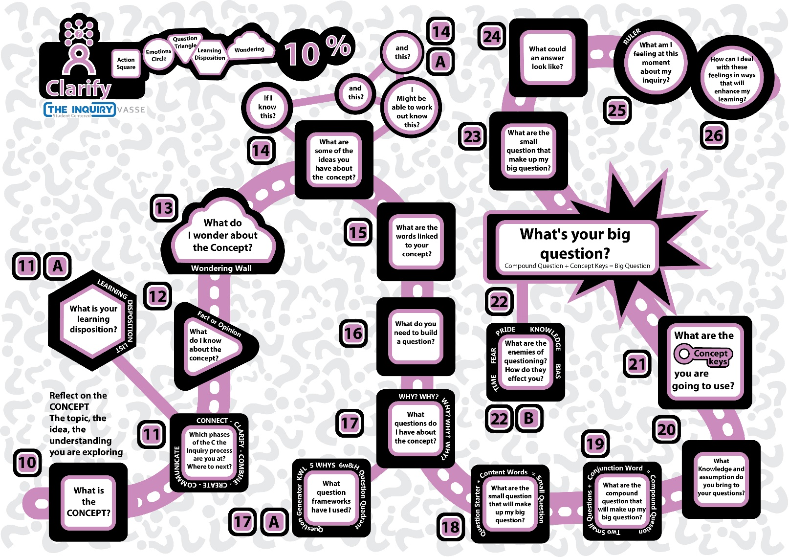
CLARIFYING THE CONCEPT
10: WHAT IS THE CONCEPT? This is the topic, the idea, the understanding you are exploring.
________________________________________________________________________________________________________________________________________________________________________________________________________________________________________________

11: What are the phases of the “C the Inquiry” process?
1:_______________________________________________________
2:_______________________________________________________
3:_______________________________________________________
4:_______________________________________________________
5:_______________________________________________________
11A: What is your learning disposition?
 | Active listening |  | Managing Impulsivity
 | Curiosity |  | Listening and understanding with Empathy
 | Questioning and posing problems |  | Striving for accuracy
 | Responsibility |  | Gathering data through all the sense
 | Perseverance |  | Responding with wonder and awe
 | Agility and flexibility |  | Creating, imagining and innovating
 | Motivation and drive to learn |  | Remaining open to continuous learning
 | Metacognition (thinking about thinking) |  | Communicating with clarity and precision
 | Problem-solving and questioning |  | Seeking to improve
 | Finding Humour |  | Fixed Mindset? Growth Mindset? Thinking Interdependently
 | Open to mistakes |  | Embracing passion

12: What do I know about the concept?
FACT:___________________________________________________________________________________________________________________________________________________________________________________________________________________________________________
FACT:___________________________________________________________________________________________________________________________________________________________________________________________________________________________________________
FACT:___________________________________________________________________________________________________________________________________________________________________________________________________________________________________________
FACT:___________________________________________________________________________________________________________________________________________________________________________________________________________________________________________ FACT:___________________________________________________________________________________________________________________________________________________________________________________________________________________________________________
13 What do I wonder about the Concept?

Positive Ideas | Open-end ideas | Challenging Ideas
14: What are some of the ideas you have about the concept?

14 A: If I know this? and this? and this? I Might be able to work out this?
I know this about the concept:
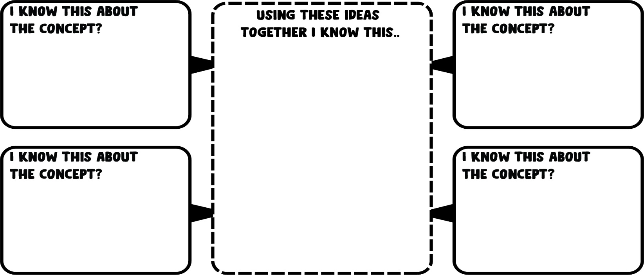
15: What are the words linked to your concept
 | WORD | MEANING
1
2
3
4
5
6
7
8
9
10
11
12
13
14
15
16
17
18
19
20
 | WORD | MEANING
21
22
23
24
25
26
27
28
29
30
31
32
33
34
35
36
37
38
39
40

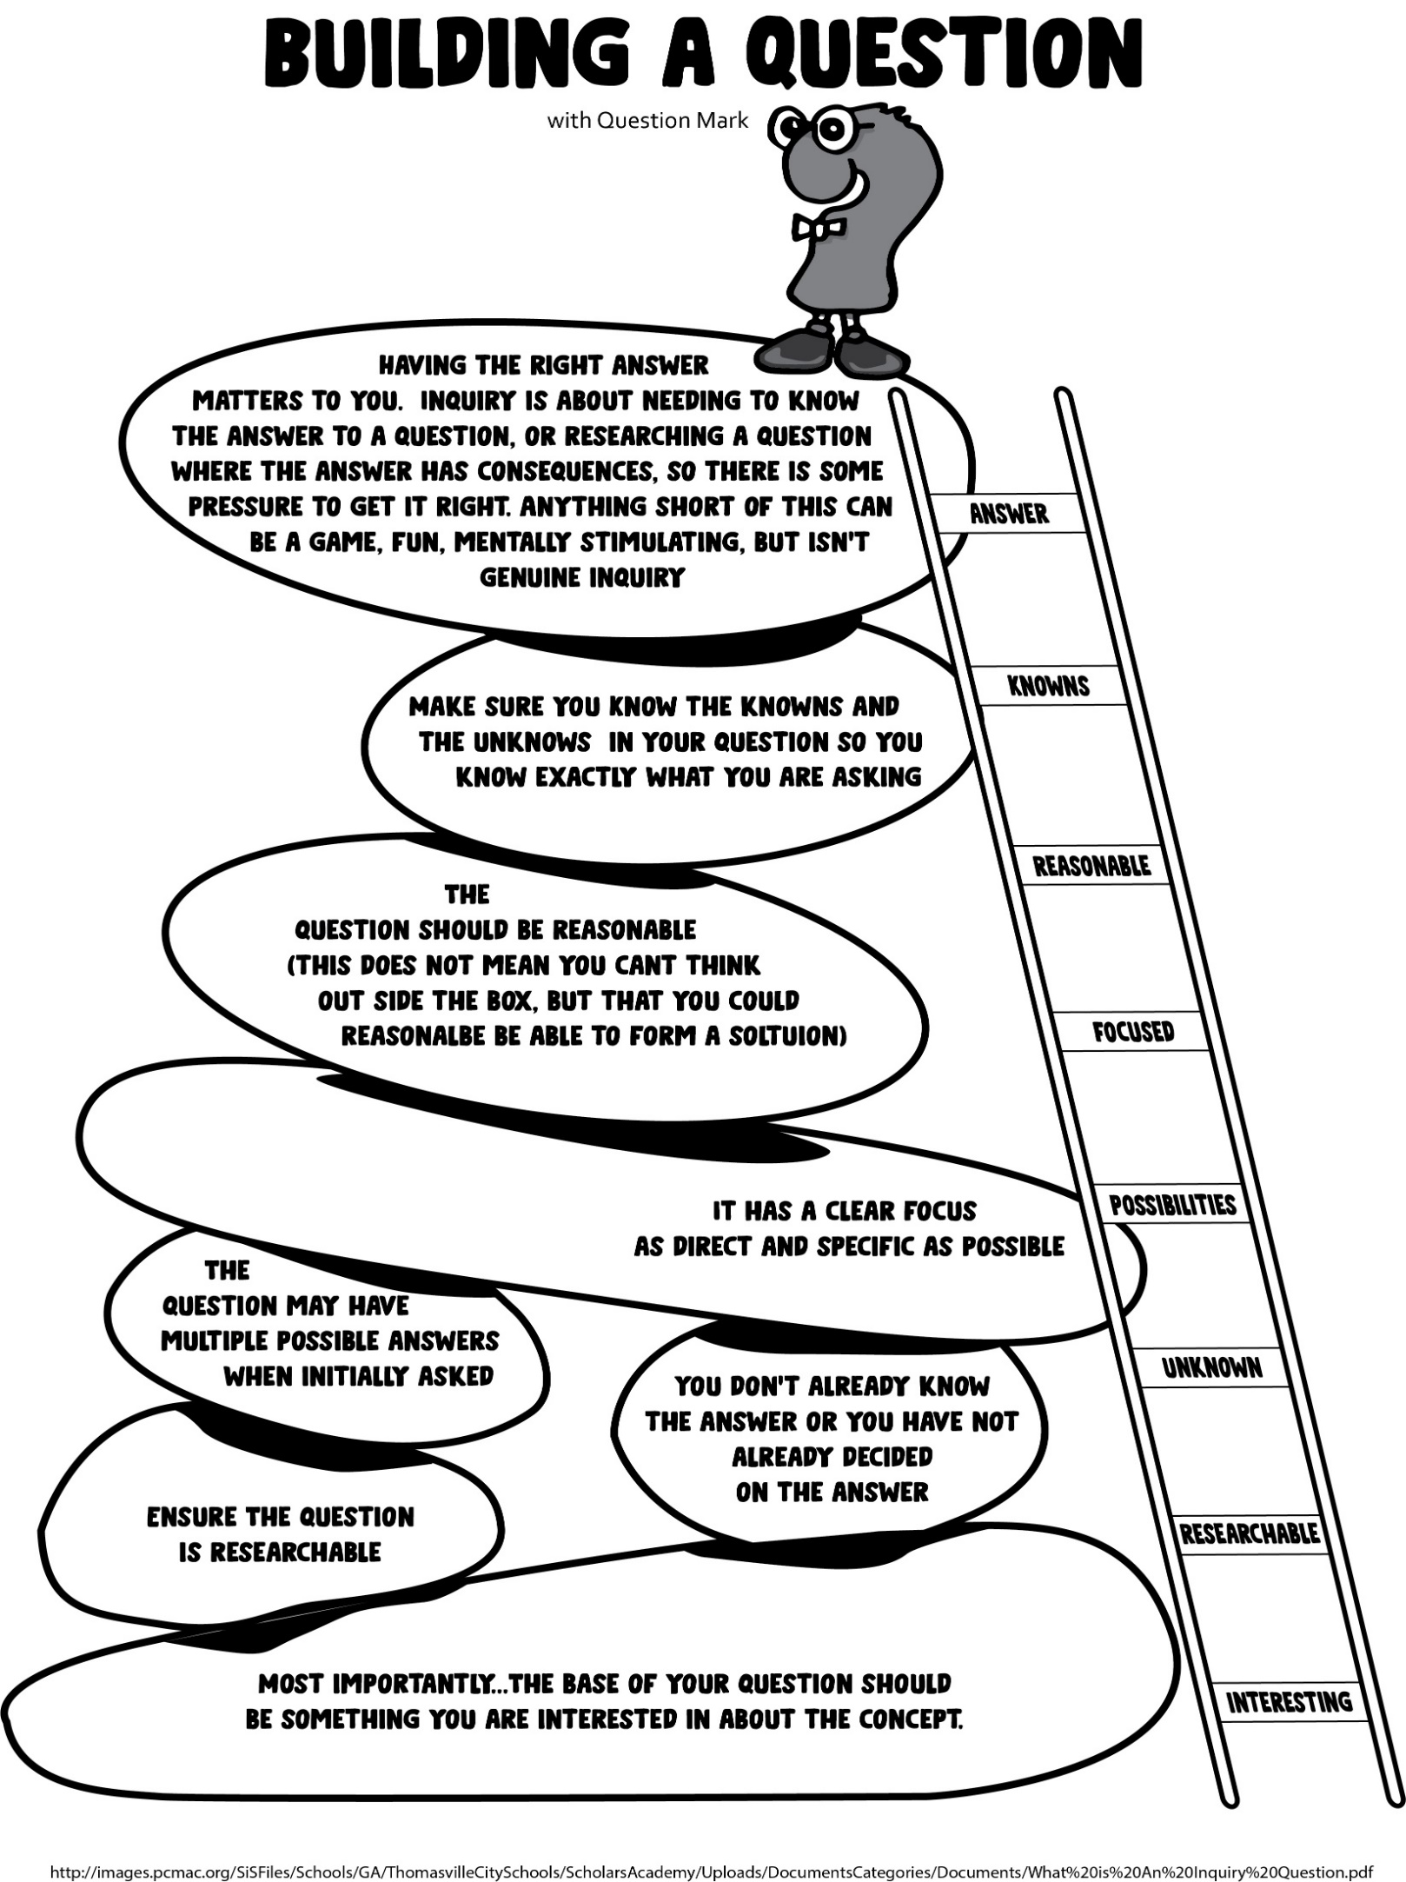
16 What do you need to build a question?
17 What questions do I have about the concept? (Question prompts)
 | Would?
 | What?
 | Who?
 | Where?
 | When?
 | How?
 | Should?
FIVE WHYS? | WHY?
 | WHY?
 | WHY?
 | WHY?
 | WHY?
17 A What question frameworks have I used?
I Have Used it | Name | Description
 | Question Generator
 | KWL
 | 5 WHYS
 | 6w&H
 | Question Quadrant

18 What are the small question that will make up my big question?
Question Starter + Content Words = Small Question

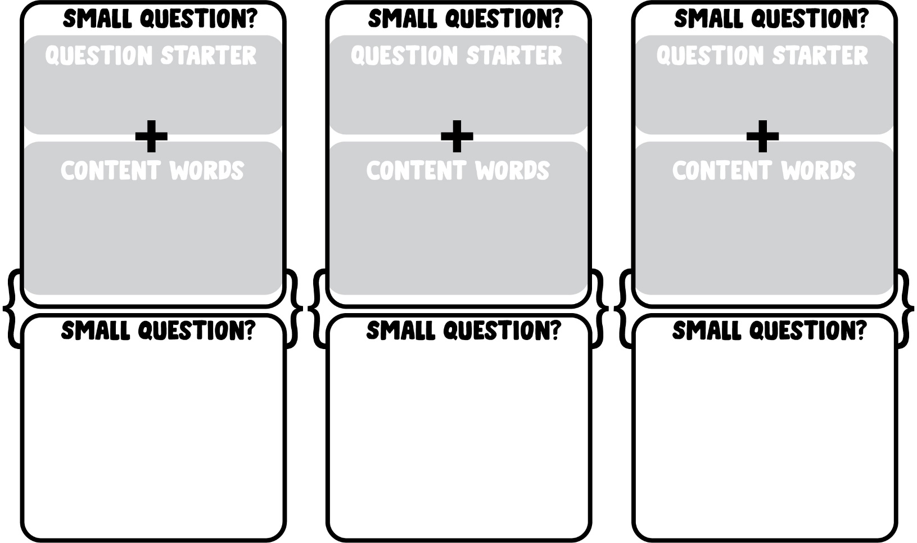
Question Starters: Where? Should? How? Why? Would? Who? What? When?

19 What are the compound question that will make up my big question?
Two Small Questions + Conjunction Word = Compound Question
Coordinating Conjunctions: And, Or, But, Nor, So, For, Yet
Subordinating Conjunctions: After, Although, As, As If, As Long As, Because, Before, Even If, Even Though, If, Once Provided, Since, So That, That, Though, Till, Unless, Until, What, When, Whenever, Wherever, Whether, While
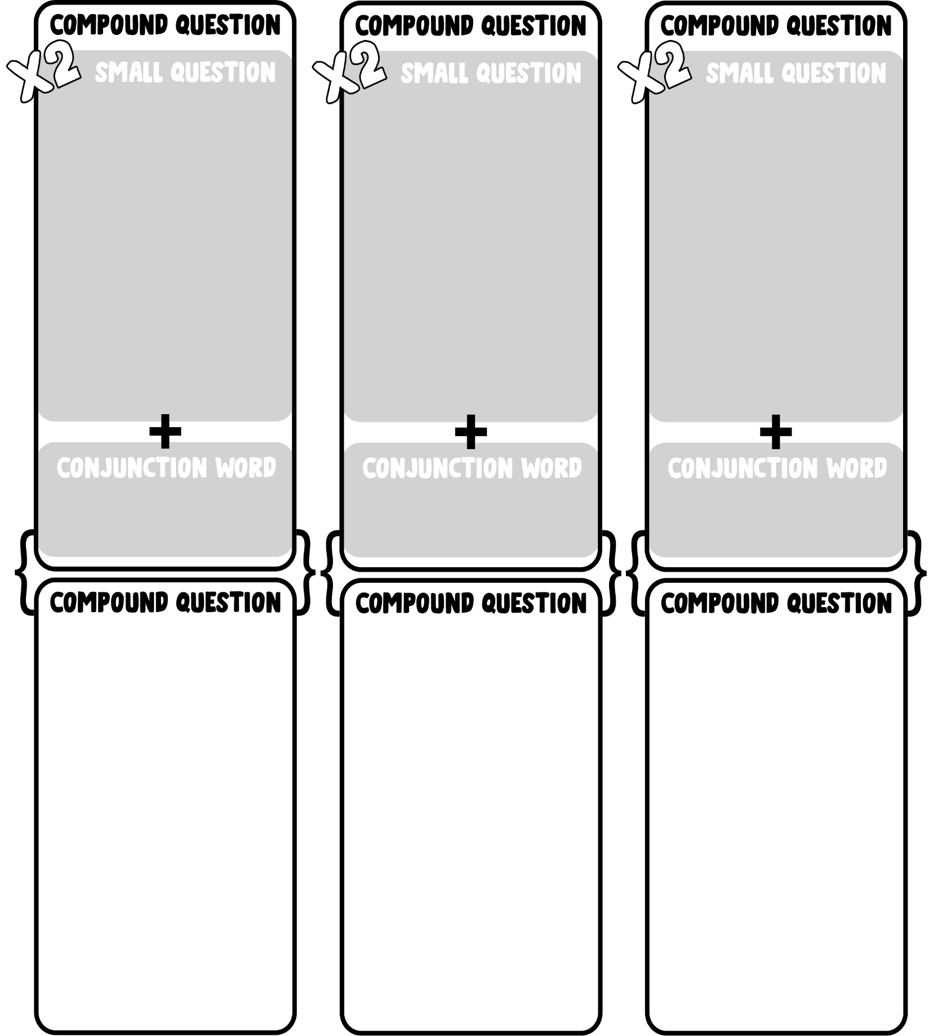
20 What Knowledge and assumption do you bring to your questions?
This is a really Trick question try to think about all the different answers
Compound question: ____________________________________________________________________________________________________________________________________________________________________________________
knowledge: Facts, information, and skills acquired through experience or education
____________________________________________________________________________________________________________________________________________________________________________________
________________________________________________________________________________________________________________________
Assumptions: A thing that is accepted as true or as certain to happen, without proof
____________________________________________________________________________________________________________________________________________________________________________________________________________________________________________________________________________________________________________
Compound question:
____________________________________________________________________________________________________________________________________________________________________________________
knowledge: Facts, information, and skills acquired through experience or education
____________________________________________________________________________________________________________________________________________________________________________________
________________________________________________________________________________________________________________________
Assumptions: A thing that is accepted as true or as certain to happen, without proof
____________________________________________________________________________________________________________________________________________________________________________________________________________________________________________________________________________________________________________
21 What are the concept keys you are going to use?
 | Concept Key | Example
1 | Adaptations: The process of change to become better suited to an environment.
2 | Causes: Something that brings about an effect or a result.
3 | Changes: Makes or becomes different.
4 | Characteristics: A feature or quality belonging typically to a person, place or thing.
5 | Communicate: Share or exchange information, news or ideas.
6 | Compare: Estimate, measure, or note the similarity or differences between.
7 | Conditions: Factors affecting the way in which people and animals live.
8 | Connections: The state of being connected or linked.
9 | Consequences: The effect, result, or outcome of something that occurred earlier.
10 | Effects/Results: A thing that is caused or produced by something else.
11 | Importance: The significance of a person, thing or idea.
12 | Relationship: The way in which two or more people or things are connected.
13 | Roles: The position or purpose that someone or something has in a situation.
14 | Structure: To establish the relationship between the components of something.
15 | Lifestyle: The way in which a person or animal lives.
16 | Survival/Defence: The process of staying alive in the presence of or despite difficult conditions.
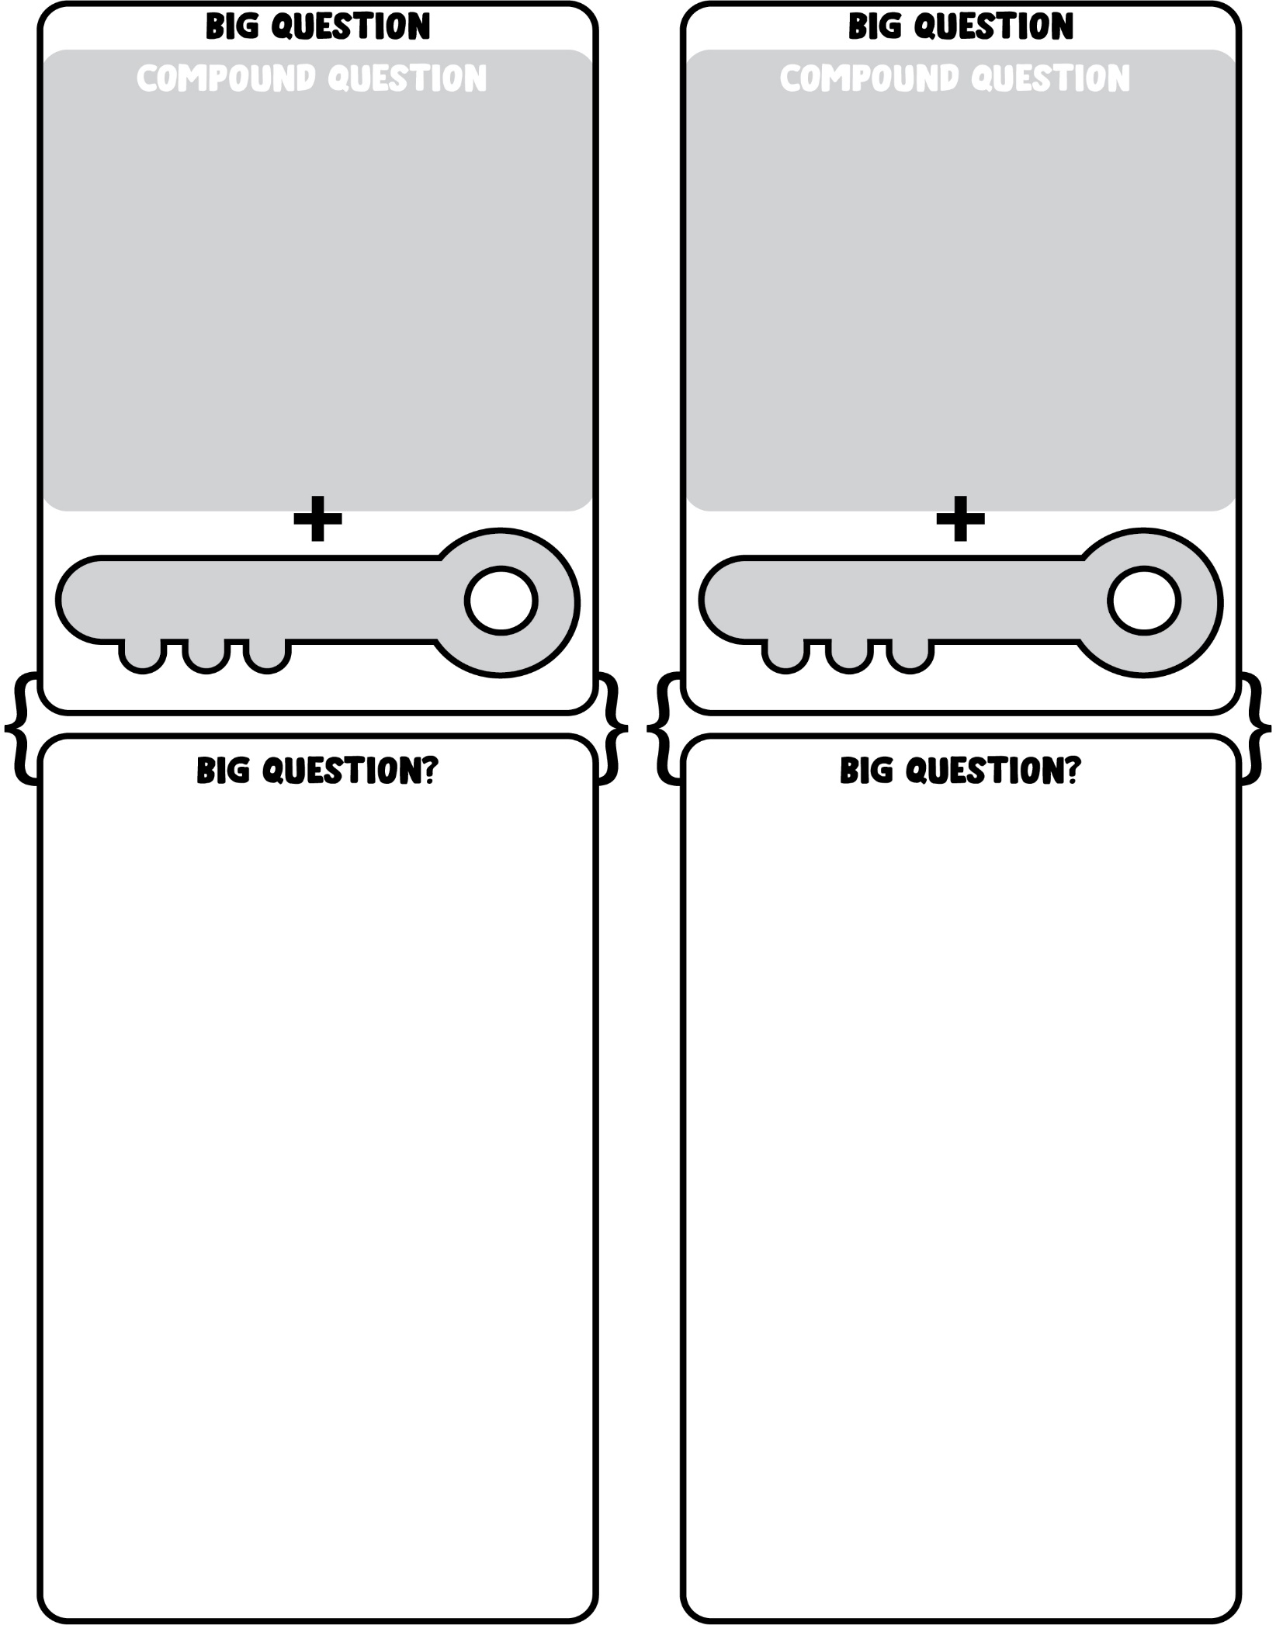
22 What's your big question?
Compound Question + Concept Keys = Big Question

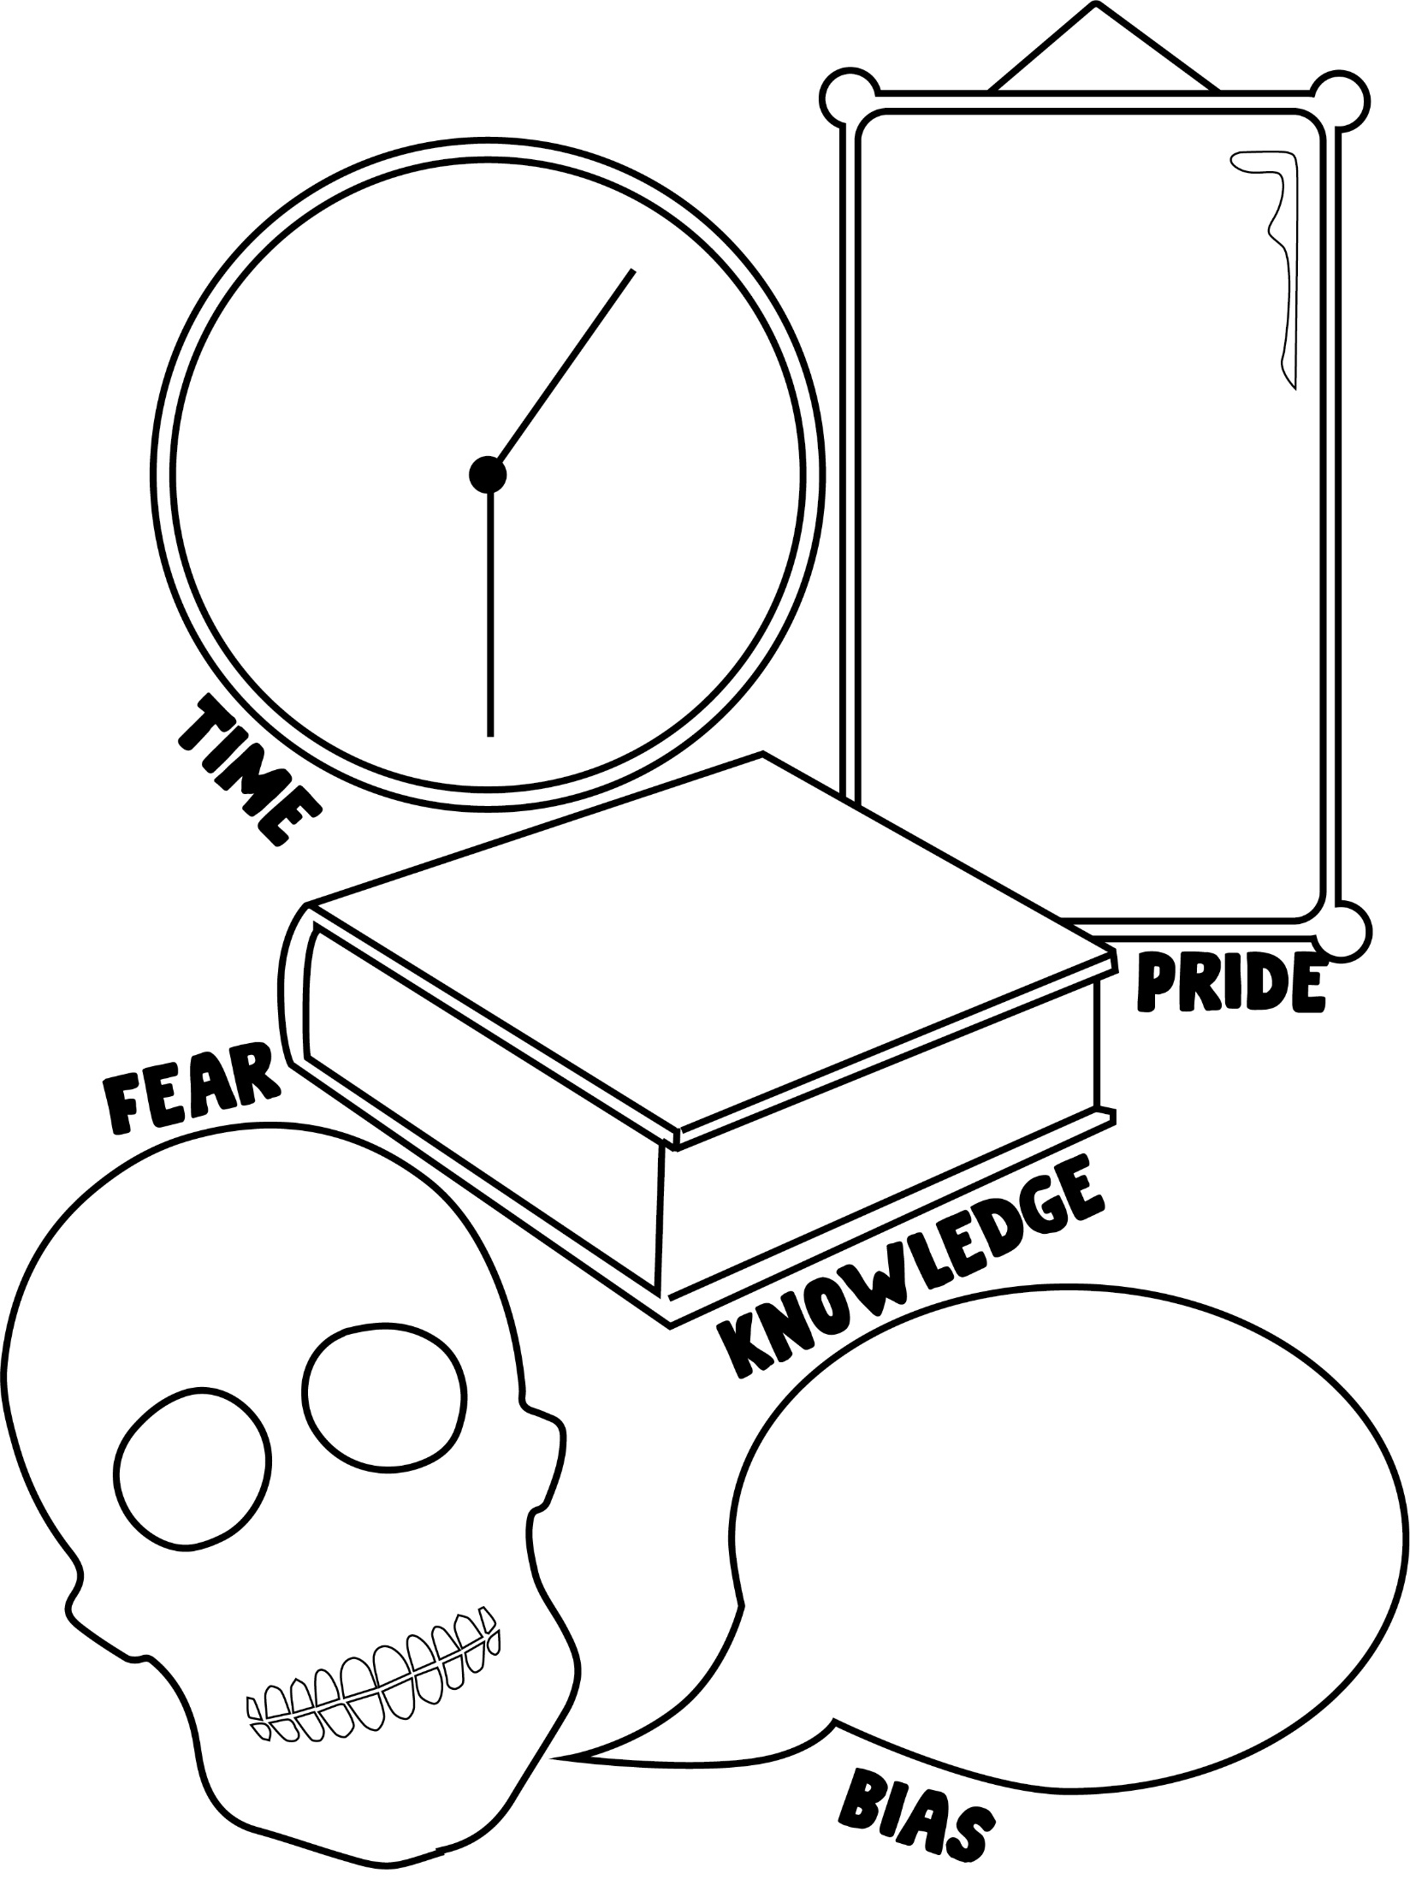
22 B What are the enemies of questioning?
How do they affect you asking questions?

23 What are the small question that make up my big question?
________________________________________________________________________________________________________________________________________________________________________________________________________________________________________________________________________________________________________________________________________________________________________________________________________________________________________________________________________________________________________________________________________________________________________________________________________________________________________________________________________________________________________________________________________________
24 What could an answer look like?

25 What am I feeling at this moment about my inquiry?
____________________________________________________________________________________________________________________________________________________________________________________________________________________________________

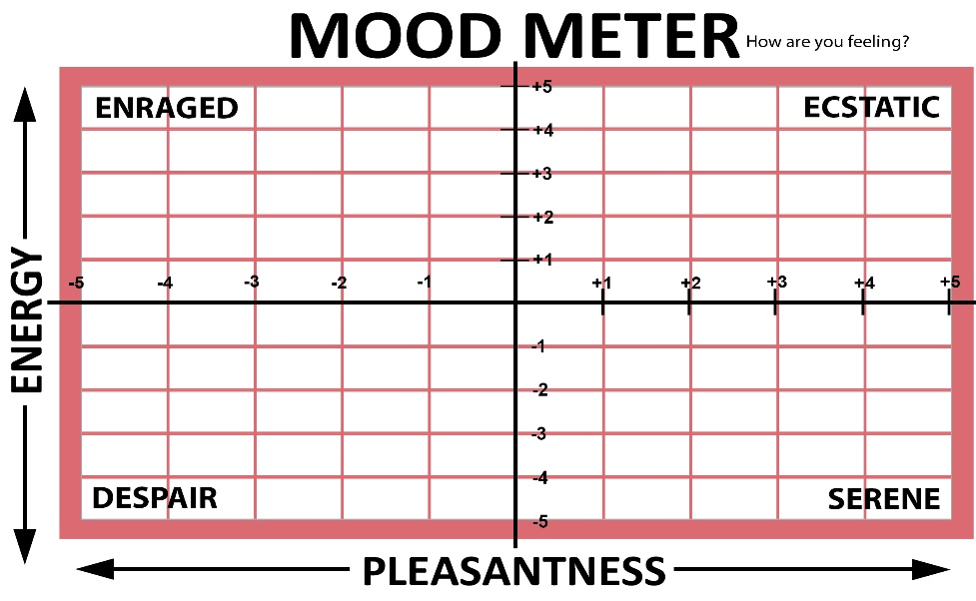

26 How can I deal with these feelings in ways that will enhance my learning?
________________________________________________________________________________________________________________________________________________________________________________________________________________________________________________________________________________________________________________________________________________________________________________________________________________________________________________________________________________________________________________________________________________________________________________________________________________________________________________________________________________________________________________________________________________

