Human Camera: A Mindfulness Activity to Engage the Senses
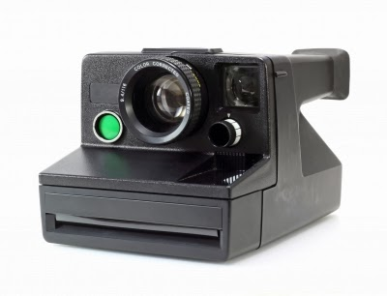
Anusorn P nachol for freedigitalphotos.net
Human Camera is a sample activity from the book Planting Seeds: Practicing Mindfulness with Children, and is reprinted here with permission from publisher Parallax Press.
Planting Seeds was recommended by Meena Srinivasan as one of theThe Best Children's Books About Mindfulness.
Have the children get into pairs. One child is the camera; the other is the photographer.
The photographer walks behind her "camera," with hands on her camera's shoulders. She carefully guides her partner, who keeps his eyes closed. She will have the chance to make three photos.
She can guide her camera to just the right spot, either lifting his head up or down, to get the right angle. When she's ready to take the picture, she gently squeezes her partner's shoulders.
He can open his eyes momentarily, and his partner can "take the picture." Then he must close them again right away.
After the third snapshot, have the partners switch.
From Planting Seeds: Practicing Mindfulness with Children (2011) by Thich Nhat Hanh and the Plum Village Community. Reprinted with permission of Parallax Press, Berkeley, California.www.parallax.org

